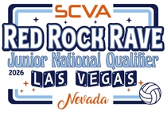

PLAY WITH PURPOSE
SCVA x Molten Fundraiser at the Red Rock Rave 2.
The SCVA has partnered with Molten to support
Stand Up To Cancer
Special Fundraiser Volleyball
Purchase the featured volleyball and help make a difference—
ALL proceeds will be donated to cancer research.
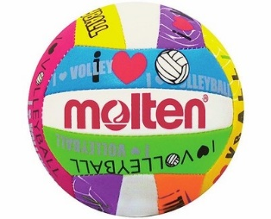
DOUBLE THE IMPACT
The SCVA will MATCH ALL FUNDS raised, doubling your contribution to the fight against cancer!
SHOW YOUR SUPPORT
If possible, wear PINK on the final day of competition
and stand united in the fight against cancer!

Together, we can serve up hope!
